**Native extensions**

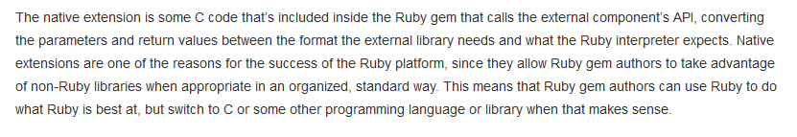

Once you installed rails you need to install native json, native byebug and god knows what other shit-ton of useless piece of crap.

**Creating an app**

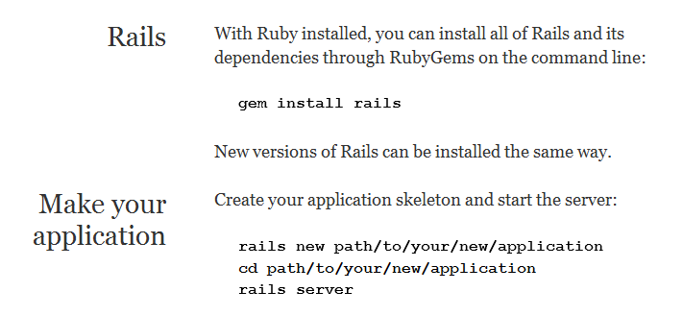

first go to the terminal and type:

$ rails new MySite

$ bundle install

$ rails server

**request/response cycle**

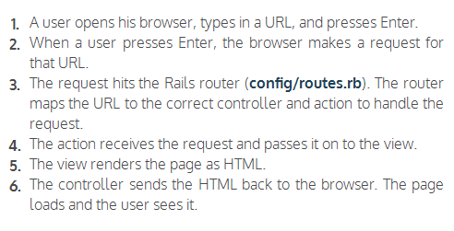

So, when you build a rail app, you need to think about creating a route, a controller and a view.

Creating the controller

$ rails generate controller Pages

Then we open the applicationController.rb file and create a new class called PagesController that is an extension of application controller.

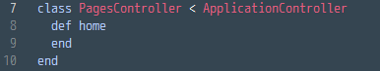

Creating the route

Next we go to config/routes.rb and type in the method:

http://i.gyazo.com/b99bdd940aa8d8aa9063053c57d5e3af.png

Creating the view

Now we just need to configure what the user will see when he goes to [www.mySite.com/welcome](http://www.mySite.com/welcome). We just go to app/views/pages/home.htmLerb (htmLerb is the equivalent of phtml) and type in the tags and code we want to display (the css is accessible at app/assets/stylesheets/pages.css.scss

To sum things up, this is how we created our first page in ruby on rails:

